**2190151 Computer Programming lab**

**Lab 1: Introduction to M5 stack, Basic C programming and LCD graphics**

**Objectives:**

1. Student is able to install Arduino IDE libraries and drivers for M5stack development kit.

2. Student is able to write programs to display charaters or pattern on M5stack LCD display.

3. Student is able to create simple temporal graphic pattern.

**Background**

M5Stack is a robust, open source development kit with stackable modules, user-friendly IDE, enabling rapid and high-quality prototyping. The core module contains ESP32, 2.0 inch TFT-LCD 320x240 display, 3 buttons, 1 W speaker, I/O extension, TF-card, i2C bus etc.

In this semester, we will learn programming with this kit and crafting a creative project with M5stack.

**Task 1: Installing Arduino IDE, libraries and drivers.**

**Step 1. Please, visit the official website** [www.arduino.cc](http://www.arduino.cc)

**Step 2. Select the SOFTWARE/DOWNLOAD section (Fig. 1.1);**

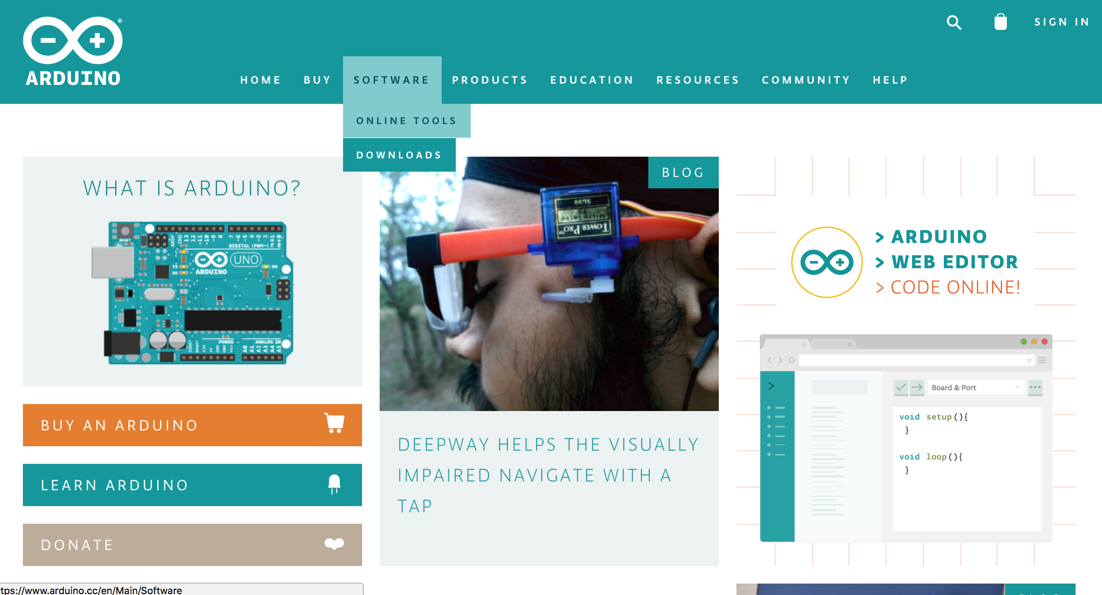

Fig.1.1 Arduino website for download IDE

**Step 3. Download the archive with Arduino-IDE 1.8.5 windows ZIP file and extract it into a new folder called “Arduino-ESP32-IDE” (Fig. 1.2)**

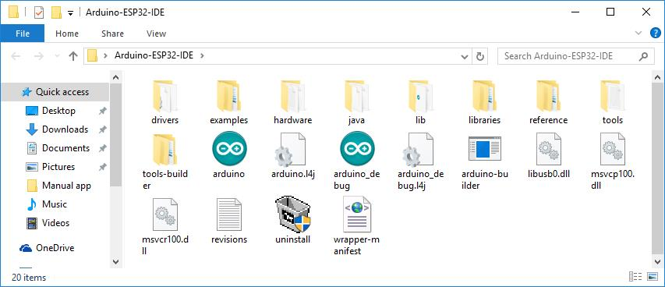

Fig. 1.2 folder to locate Arduino IDE software

**Step 4. Download the CP210X drivers for your operating system and extract it to a new folder (Fig. 1.3); or alternately download driver software from this manufacturer’s link:**

[**https://www.silabs.com/products/development-tools/software/usb-to-uart-bridge-vcp-drivers**](https://www.silabs.com/products/development-tools/software/usb-to-uart-bridge-vcp-drivers)

but do NOT use the Windows 10 Universal (v10.1.1) driver! Or the default MacOS driver. If you happen to download the Universal version, you may need to manually uninstall and delete the driver software before re-install the correct version.

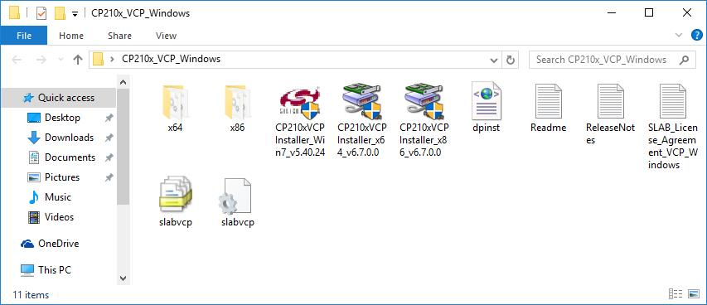

Fig.1.3 download drivers

**Step 5. M5Stack connect to Your computer using the USB cable C (Fig. 1.4);**

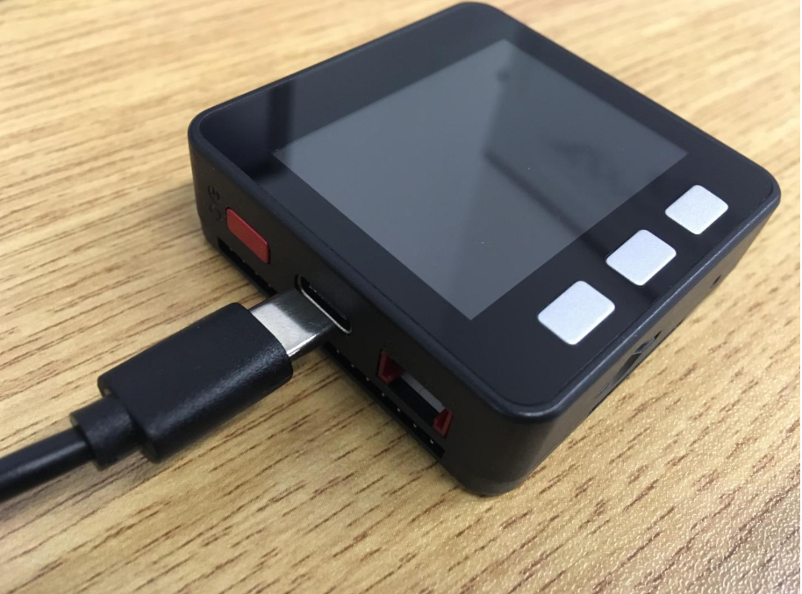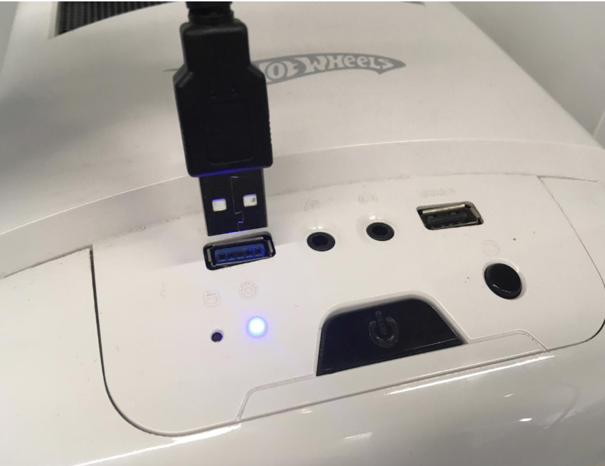

Fig 1.4 connect M5stack to your computer

**Step 6. Select the appropriate version of the drivers according to your OS and install:**

**You may also need to check if you run 32bit or 64bit windows OD too.**

* Windows 7, CP210xVCPInstaller_Win7_v5.40.24.exe; (choose 32 bit OS for computers in lab)
* Windows 8,10 x86 10, CP210xVCPInstaller_x86_v6.7.0.0.exe;
* Windows 8, 10 x64 10, CP210xVCPInstaller_x64_v6.7.0.0.exe.
* MacOS 10.6 up use driver version 4.x.x (locate in the legacy driver link)

**Step 7. Open Arduino and goto Arduino/preference in the box “Additional Board Manager URLs”** insert <https://dl.espressif.com/dl/package_esp32_index.json> and click “OK”

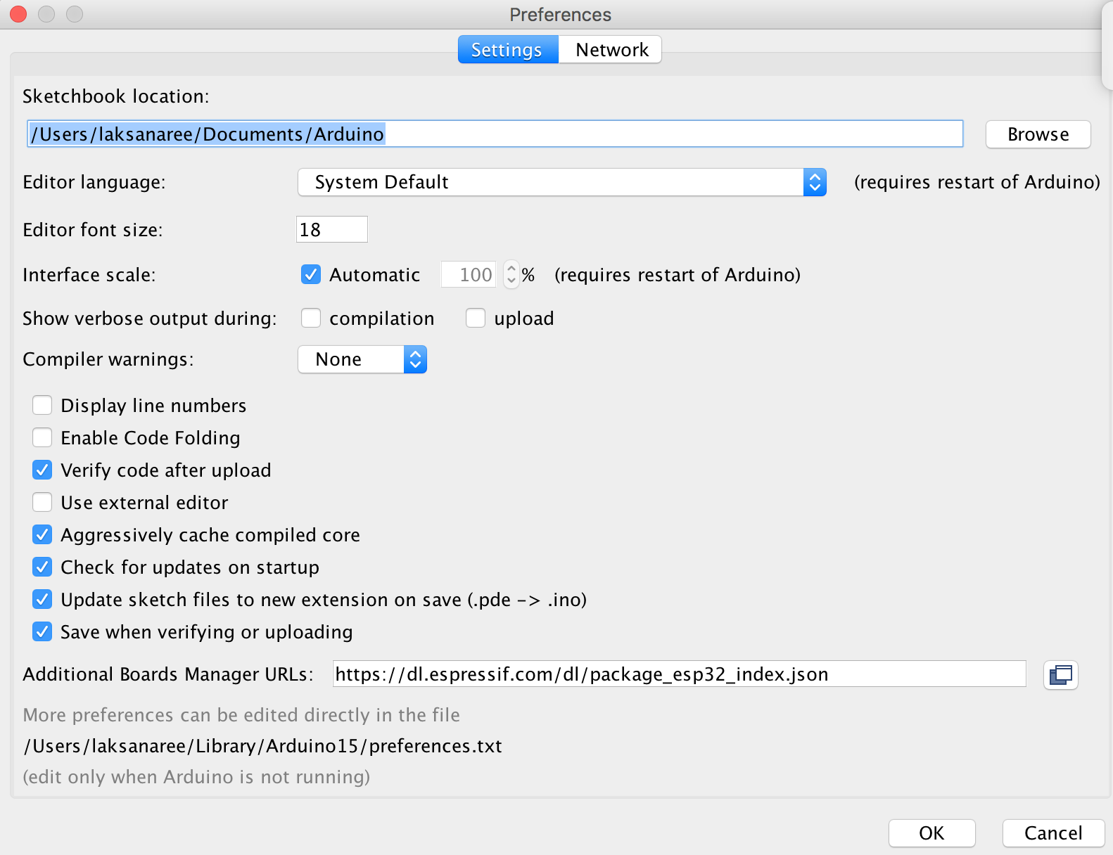

Fig.1.5 Insert Additional boards manager URLs

**Step 8. Goto menu board Tool/BoardXXX/BoardManager then enter “esp32” in the search box and enter. Afterthat click “More Info” and click “install”**

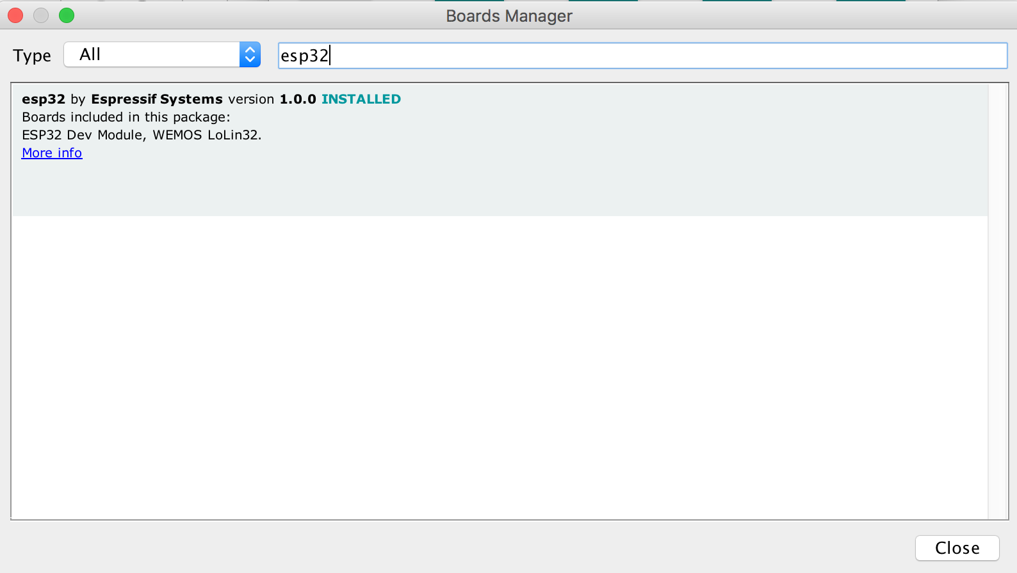

Fig 1.6 window shown for board manager

**Step 9. Add library: goto menu Sketch/include Library/Manage library and type “m5stack” in the search box, the select Library for m5stack core development kit and install.**

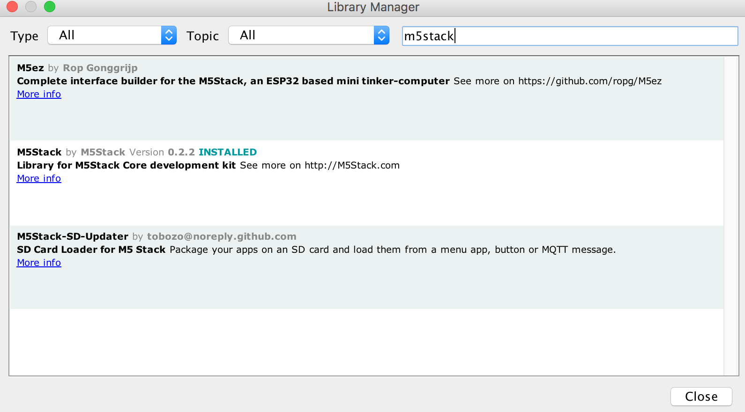

Fig.1.7 Window shown for include library

**Task 2: Create first program**

**Step 1 Go to the folder Arduino-ESP32-IDE and open the app arduino.exe ;**

**Step 2 Step 9. In the Sketch menu, select Include Library, M5Stack**

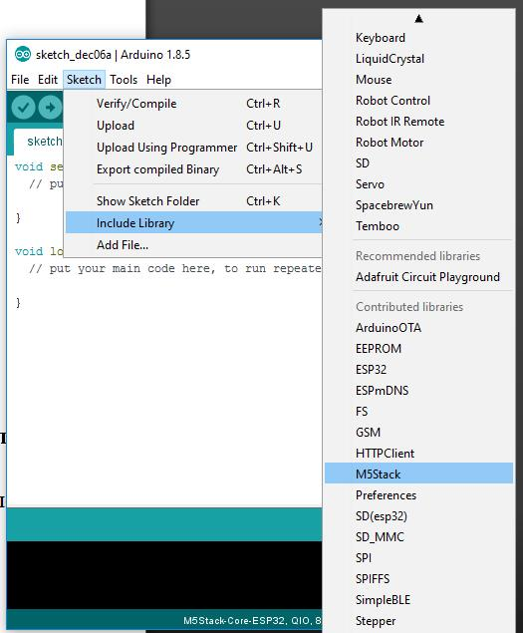

Fig 2.1

**Step 3. On the File menu, select Examples, M5Stack, Basics, Hello**

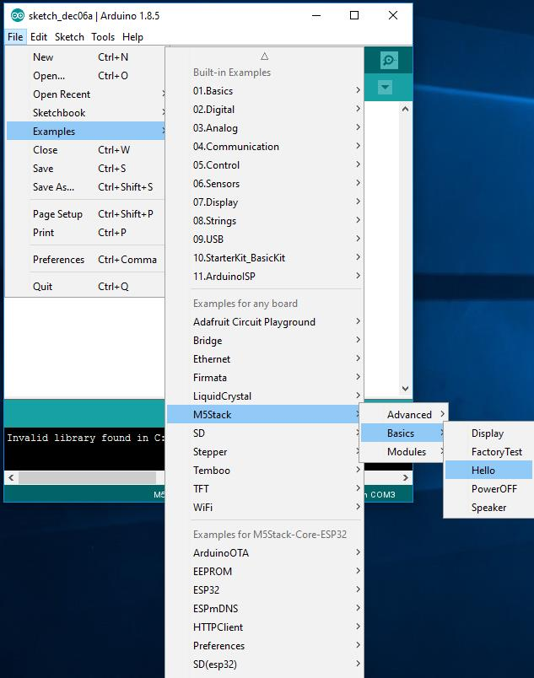

Fig. 2.2

**Step 4. In the Tools menu, click Board index, M5Stack-Core-ESP32**

**Step 5. In the Tools menu, select Port that corresponds to the COM port , where the device Silicon Labs CP210x USB to UART Bridge (you can learn with the help of the device Manager in Windows under Ports (COM & LPT))**

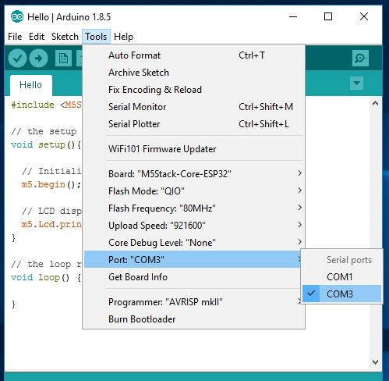

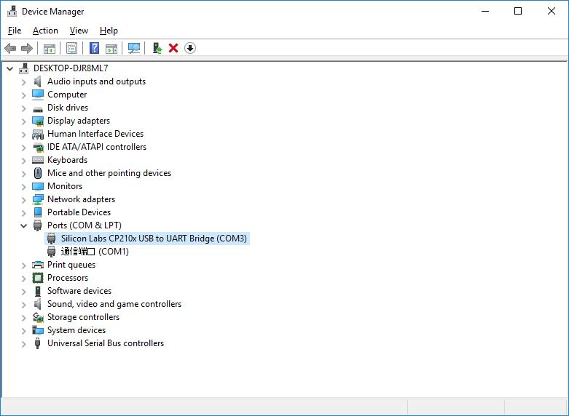

Fig 2.3 Fig 2.4

**Step 6. Click the Upload button (Fig. 5);**

[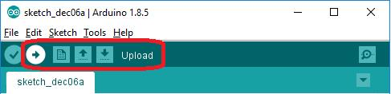](https://pp.userapi.com/c834302/v834302415/4c0c4/fb4LEvLY2ws.jpg)

Figure 2.5. Upload the firmware to the device

**Step 7. After the end of the flashing process you will receive the following text in a report field (Fig. 6);**

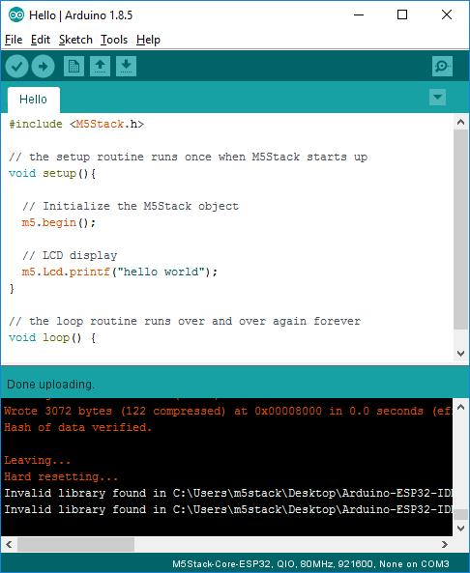  
Figure 2.6. Report about the successful completion of the firmware

**Step 8. Pay attention to the screen of the device (Fig 7).**

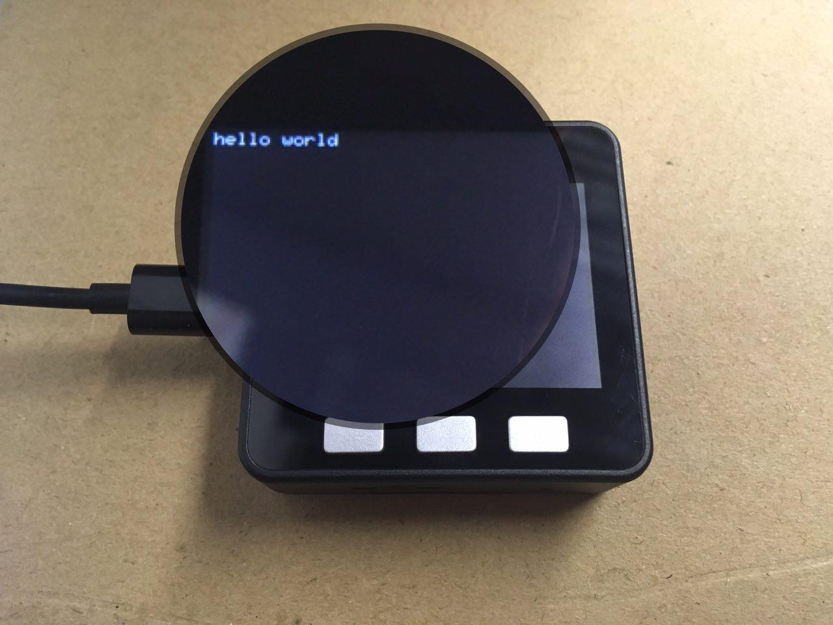  
Figure 2.7. Hello World on the screen of the device

**Step 9. Prepare software is completed.**

**Task 3: LCD. Show graphic**

**This task focuses on the integrated LCD display. We consider the main functions for working with graphics M5Stack.**

**Step 1. Learn the codes of the colors in the 565 format in figure 1;**

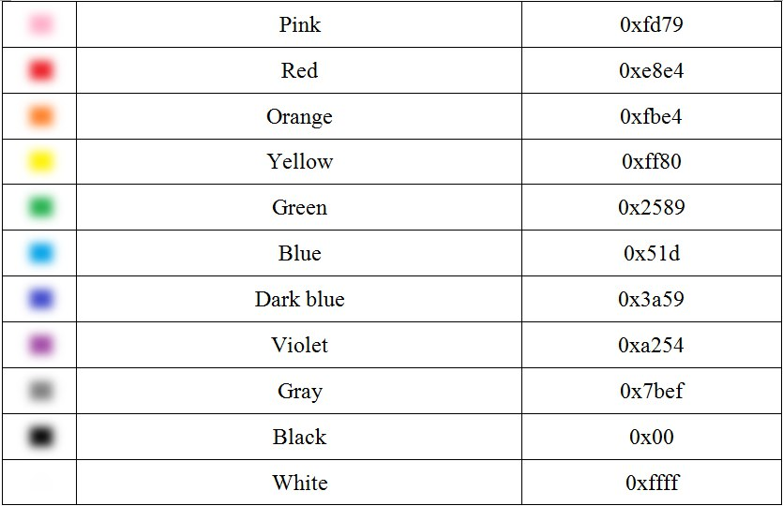  
Figure 3.1. Codes the main color in hexadecimal

**Step 2. Learn the functions for work with display in list 2;**

List 2. Functions for working with built-in LCD display

* M5.Lcd.setBrightness(uint8_t brightness); Set the screen brightness
* M5.Lcd.drawPixel(int16_t x, int16_t y, uint16_t color); Paint the pixel located at the X and Y coordinates (relative to the upper left corner of the screen) to a color from 0 to 65535
* M5.Lcd.drawLine(int16_t x0, int16_t y0, int16_t x1, int16_t y1, uint16_t color); Draw a line from the point X0 and Y0 to the point X1 and Y1 with a color from 0 to 65535
* M5.Lcd.fillRect(int16_t x, int16_t y, int16_t w, int16_t h, uint16_t color); Draw a rectangle with the points X0 and Y0 to the point X1 and Y1 with width W, height H and color from 0 to 65535
* M5.Lcd.fillScreen(uint16_t color); Paint the whole screen with color 0 to 65535
* M5.Lcd.drawCircle(int16_t x0, int16_t y0, int16_t r, uint16_t color); Draw a circle with center at the point X0 and Y0, with radius R and color from 0 to 65535
* M5.Lcd.drawCircleHelper(int16_t x0, int16_t y0, int16_t r, uint8_t cornername,uint16_t color); Draw a quarter circle with the center at the point X0 and Y0, with radius R, and a quarter C, and a color from 0 to 65535
* M5.Lcd.fillCircle(int16_t x0, int16_t y0, int16_t r, uint16_t color); Draw a filled circle with center at the point X0 and Y0, with radius R and color from 0 to 65535
* M5.Lcd.fillCircleHelper(int16_t x0, int16_t y0, int16_t r, uint8_t cornername,int16_t delta, uint16_t color); Draw a filled quarter circle with the center at the point X0 and Y0, with radius R, the fourth from 0 to 255 and color from 0 to 65535
* M5.Lcd.drawTriangle(int16_t x0, int16_t y0, int16_t x1, int16_t y1, int16_t x2, int16_t y2, uint16_t color); Draw a triangle with vertices X0 and Y0, X1 and Y1, X2 and Y2 and the color from 0 to 65535
* M5.Lcd.fillTriangle(int16_t x0, int16_t y0, int16_t x1, int16_t y1, int16_t x2, int16_t y2, uint16_t color); Draw a filled triangle with vertices X0 and Y0, X1 and Y1, X2 and Y2 and the color from 0 to 65535
* M5.Lcd.drawRoundRect(int16_t x0, int16_t y0, int16_t w, int16_t h, int16_t radius, uint16_t color); Draw a rectangle with the points X0 and Y0 of width W, height H, radius of the rounded corners R and the color from 0 to 65535
* M5.Lcd.fillRoundRect(int16_t x0, int16_t y0, int16_t w, int16_t h, int16_t radius, uint16_t color); Draw a filled rectangle with the points X0 and Y0 of width W, height H, radius of the rounded corners R and the color from 0 to 65535
* M5.Lcd.drawBitmap(int16_t x, int16_t y, const uint8_t bitmap[], int16_t w, int16_t h, uint16_t color); Draw bitmap with points X0 and Y0, the bit array of brightness from 0 to 255, width W, height H and color from 0 to 65535
* M5.Lcd.drawRGBBitmap(int16_t x, int16_t y, const uint16_t bitmap[], int16_t w, int16_t h); Draw a colored bitmap from the point X0 and Y0, an array of the color bit from 0 to 65536, width W, height H
* M5.Lcd.drawChar(uint16_t x, uint16_t y, char c, uint16_t color, uint16_t bg, uint8_t size); to Draw a character with points X0 and Y0, with the character code C, color from 0 to 65535, background color, from 0 to 65535 in size from 0 to 256
* M5.Lcd.setCursor(int x, int y) Set the location of the cursor to the coordinates X and Y
* M5.Lcd.setTextColor(uint16_t color); to Set the text color from 0 to 65535
* M5.Lcd.setTextColor(uint16_t color, uint16_t backgroundcolor); Set the color of the text from 0 to 65535, and the background color behind it 0 to 65535
* M5.Lcd.setTextSize(uint8_t size); to Set the size of text from 0 to 255
* M5.Lcd.setTextWrap(boolean w); Use the wrap text to true or false
* M5.Lcd.printf(); Display the text on the screen

**Step 2. Create a new sketch in the Arduino IDE. On the File menu, select New (Fig. 3.2);**

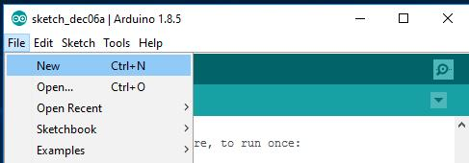  
Figure 3.2. Create a new sketch

**Step 3. Draw on the screen shaded in different colors on the circle (Fig. 3).**

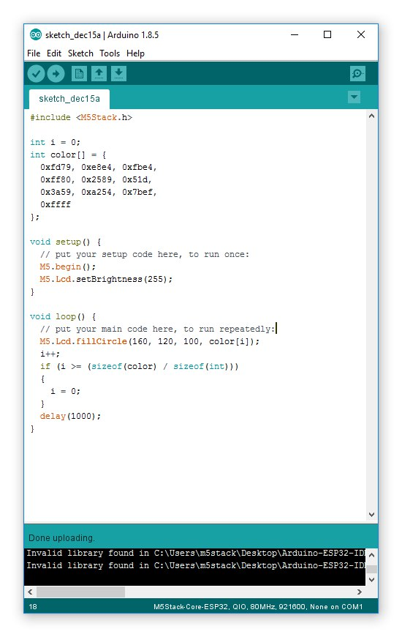  
Figure 3.3. The sketch

**Step 4. Click the Upload button (Fig. 3.4) in order to flash the device;**

[](https://pp.userapi.com/c841031/v841031804/4b556/6ET8REQao8I.jpg)  
Figure 3.4. Download the firmware to the device

**Step 5. When the device firmware is completed, the device screen will display a circle of different colors**

**Step 6. Try to change the program to draw different image on the display**



**Finish LAB 1**

2190151 Computer Programming Laboratory Group No.______________

Name 1________________________ID 1___________________________

Name 2________________________ID 2___________________________

Laboratory 1: **Introduction to M5 stack, Basic C programming and LCD graphics**

**Task 1: Installing Arduino IDE, libraries and drivers.**

Graded by _____________________Time________________



**Task 2: Create first program**

Graded by _____________________Time________________

**Task 3: LCD. Show graphic/ Yin Yang Graphics**

Graded by _____________________Time________________

Answer these 5 questions:

1. What do you like most about this lab?

|  |
| --- |
|  |
|  |
|  |
|  |

1. What do you don’t like about this lab?

|  |
| --- |
|  |
|  |
|  |
|  |

1. Which concepts is the most difficult or confusing in this lab?

|  |
| --- |
|  |
|  |
|  |
|  |

1. What do you want to learn more after doing this lab?

|  |
| --- |
|  |
|  |
|  |
|  |

1. Do you have any suggestion for this lab?

|  |
| --- |
|  |
|  |
|  |
|  |